Experiment Number : 9 Date: 18-02-26

Implementation of a Java Program to import packages using different methods

Aim:
Write a Java program to import packages using different methods for different use cases.

PRE LAB EXERCISE
QUESTIONS
- How to import a single class and multiple classes from a package in Java?
Import a single class:
import java.util.ArrayList;
Import multiple classes (entire package):
import java.util.*;

- Which package is always imported by default in every Java class?
java.lang
It is imported automatically and has classes that are often used, such as String, System, Math, Integer, and so on.

IN LAB EXERCISE
Objective
To understand and implement the Java packages using different methods and import them.
Problem
Define a package named ‘useFul’ with a class names ‘UseMe’ having following methods:
1) area()—To find the area of a shape.
2) salary()—To figure out the salary based on the basic salary, da, and hRA.
3) percentage()—To figure out the percentage based on the total marks and the marks earned.
4) Create a program called "Package Use" that imports the "useFul" package and uses the area() method.
5) Make a program called "manager" Source Code
//Package Creation:
package useFull;
import java.util.*;
public class UseMe
{
Scanner obj=new Scanner(System.in);
public static void area()
{
class method{
void aos(int a)
{
System.out.print("\nArea of square with length "+a+" is "+(a*a));
}
void aor(int a,int b)
{
System.out.print("\nArea of reactangle with dimensions "+a+" & "+b+" is "+(a*b));
}
void aoc(int r)
{
double a=3.14*r*r;
}
System.out.print("\nArea of circle with radius "+r+" is "+a);
}
void aot(int a,int b)
{
float ar=(a*b)/2;
System.out.print("\nArea of triangle with dimensions "+a+" &"+b+" is "+ar);
} }
Scanner obj=new Scanner(System.in);
method m=new method();
System.out.print("\n1.Square\n2.Rectangle\n3.Circle\n4.Triangle\nSelect the shape\n");
int ch=obj.nextInt();
UseMe u=new UseMe();
switch(ch)
{
case 1:System.out.print("\nEnter the length of side of square : ");
int s=obj.nextInt();m.aos(s);
break;
case 2:System.out.print("\nEnter the dimensions of rectangle : ");
int l=obj.nextInt();
int b=obj.nextInt();
m.aor(l,b);
break;
case 3:System.out.print("\nEnter the radius of circle : ");
int r=obj.nextInt();
m.aoc(r);
break;
case 4:System.out.print("\nEnter the dimensions of triangle : ");
int ba=obj.nextInt();
int w=obj.nextInt();
m.aot(ba,w);
break; } }
public void salary()
{
int ba,da,hra;
System.out.print("\nEnter the basic salary : ");
ba=obj.nextInt();
System.out.print("\nEnter the dearness allowance :");
da=obj.nextInt();
System.out.print("\nEnter the house rent allowance : ");
hra=obj.nextInt();
System.out.print("\nThe total Gross salary of employee is : "+(ba+da+hra));
}
public void percentage()
{
int n,sum=0;
float p;
System.out.print("\nEnter the total number of subjects : ");
n=obj.nextInt();
int m[]=new int[n];
System.out.print("\nEnter the marks of "+n+" subjects : ");
for(int i=0;i<n;i++)
{
m[n]=obj.nextInt();
}
for(int i=0;i<n;i++)
{
sum=sum+m[i];
}
p=sum/n;
{
System.out.print("\nPercentahe of student : "+p);
}
}
}
//Package Implementation-1:
import useFull.UseMe;
class packageUse
{
public static void main(String args[])
{
UseMe o=new UseMe();o.area();
}
}

Output
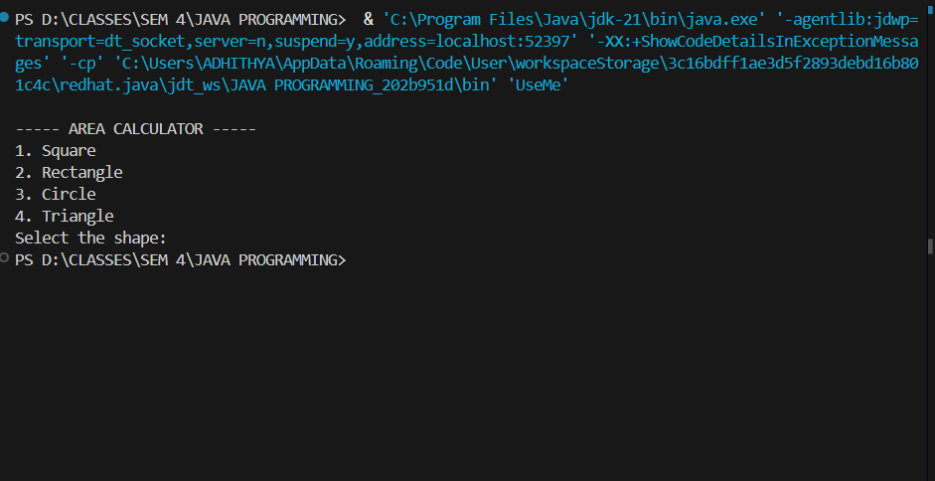
//Package Implementation-2:
import useFull.UseMe;
class manager
{
public static void main(String args[])
{
UseMe obj=new UseMe();obj.salary();
}
}

Output
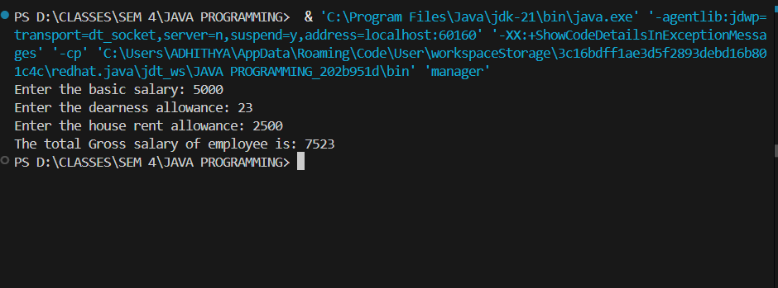
POST LAB EXERCISE
- Find the key differences between java.util and java.lang packages.
Feature | java.lang | java.util
Import | Automatically imported | Must be imported manually
Purpose | Basic language support | Utility classes & data structures
Contains | String, System, Math, Wrapper classes | ArrayList, HashMap, Scanner, Collections
Usage | Core Java features | Collection Framework, date, random, etc.

- List some of the subpackages of java.util
• java.util.concurrent
• java.util.function
• java.util.logging
• java.util.regex
• java.util.stream

ASSESSMENT

Description | Max Marks | Marks Awarded
Pre Lab Exercise | 5
In Lab Exercise | 10
Post Lab Exercise | 5
Viva | 10
Total | 30
Faculty Signature

